OPTIMIZING THE REPEATED DATA THROUGH LEXICAL ANALYSIS

PRACTICAL ASSIGNMENT REPORT
SUBMITTED TO

RAMAIAH INSTITUTE OF TECHNOLOGY
(Autonomous Institute, Affiliated to VTU)

Bangalore – 560054

SUBMITTED BY

Ajeya S H 1MS14CS146
Prasad Hegde 1MS14CS086
Prasann K P 1MS14CS087
M Gaurav 1MS14CS059

As part of the Course Compiler Design – CS1561/CS612

SUPERVISED BY

Sini Anna Alex
Assistant Professor
Computer Science & Engineering, RIT



DEPARTMENT OF COMPUTER SCIENCE AND ENGINEERING

RAMAIAH INSTITUTE OF TECHNOLOGY

Jan-May 2017
Department of Computer Science and Engineering

Ramaiah Institute of Technology
(Autonomous Institute, Affiliated to VTU)

Bangalore – 54

CERTIFICATE

This is to certify that Ajeya S H (1MS14CS146), Prasad Hegde (1MS14CS086), Prasann K P (1MS14CS087) and M Gaurav (1MS14CS059) have completed the “optimizing the repeated data through lexical analysis” as part of practical assignment. We declare that the entire content embodied in this B.E. 6th Semester report contents are not copied.

Guided by
Prof. Sini Anna Alex
(Assistant Professor, Dept. of CSE, RIT)
Submitted by
- Ajeya S H
- Prasad Hegde
- Prasann K P
- M Gaurav
Department Of Computer Science and Engineering
Ramaiah Institute of Technology
(Autonomous Institute, Affiliated to VTU)

Bangalore – 54

Evaluation Sheet

Sl. No | USN  Name | Content  and Demonstration  (5) | Speaking Skills  (1) | Teamwork  (1) | Neatness and care  (1) | Effectiveness  & Productivity (2) | Total Marks  (10)
1. | Ajeya S H
2. | Prasad Hegde
3. | Prasann KP
4. | M Gaurav

Evaluated By

Name: Sini Anna Alex
Designation: Assistant Professor
Department: Computer Science & Engineering, RIT
Signature:

HOD, CS
Contents:
- Abstract
- Source Code
- Result Snapshots
- References

Abstract

Lexical analysis is the first phase of a compiler. It takes the modified source code from language preprocessors that are written in the form of sentences. The lexical analyzer breaks these syntaxes into a series of tokens, by removing any whitespace or comments in the source code.
If the lexical analyzer finds a token invalid, it generates an error. The lexical analyzer works closely with the syntax analyzer. It reads character streams from the source code, checks for legal tokens, and passes the data to the syntax analyzer when it demands.
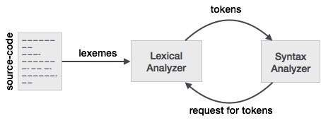

Optimizing the repeated data through lexical analysis involves the identification of various repeated sentences, and sentences with similar meaning given in a text file. The procedure is initiated by providing the text file to the lexical analyzer, which initially tokenizes the given words. The tokenized words in a sentence are compared with various other sentences using the machine learning concept of Cosine Dissimilarities. Cosine Dissimilarities is a measure of dissimilarities between two non-zero vectors of an inner product space that measures the cosine angle between them. After the conversion of words into vectors, the angle between them is found out and the threshold value of similarity is considered as 0.6. If the angle is more than the threshold value, the sentences are considered similar. Based on the cosine values found the sentences can be optimized and the output obtained contains only unique, non-repetitive sentences in the given text file.
Source Code
#!/usr/bin/env python
from nltk.tokenize import sent_tokenize, word_tokenize
from nltk.corpus import stopwords
from nltk.stem import PorterStemmer
import re
import tkinter
import sys
import os
import re, math
from collections import Counter

WORD = re.compile(r'\w+')

def get_cosine(vec1, vec2):
intersection = set(vec1.keys()) & set(vec2.keys())
numerator = sum([vec1[x] * vec2[x] for x in intersection])

sum1 = sum([vec1[x]**2 for x in vec1.keys()])
sum2 = sum([vec2[x]**2 for x in vec2.keys()])
denominator = math.sqrt(sum1) * math.sqrt(sum2)

if not denominator:
return 0.0
else:
return float(numerator) / denominator

def text_to_vector(text):
words = WORD.findall(text)
return Counter(words)

def getsentences(str):
str = re.sub('\.','. ',str)
str = re.sub('\?','? ',str)
return str

def gettokens(Sentence):
tokens = []
for sentence in Sentence:
print(sentence)
tokens.append(word_tokenize(sentence))
return tokens

def main():
Sentences = []
myfile = open(str(entry1.get()),"r")
data = myfile.read()
data = data.lower();
data = getsentences(data)
Sentences = sent_tokenize(data)
#print(Sentences)
tokens = word_tokenize(data)
#print(tokens)
newsentence=""
finalsentences = []
finalsentences.append(Sentences[0])
newsentence=newsentence+Sentences[0]
flag=0
i=-1
for sentence in Sentences:
flag=0
i=i+1
if(i==1):
text1=Sentences[0]
text2=Sentences[1]
vector1 = text_to_vector(text1)
vector2 = text_to_vector(text2)
cosine = get_cosine(vector1, vector2)
if(cosine < 0.60):
finalsentences.append(Sentences[1])
newsentence=newsentence+Sentences[1]
continue
for index in range(i-1):
text1 = sentence
text2 = Sentences[index]
vector1 = text_to_vector(text1)
vector2 = text_to_vector(text2)
cosine = get_cosine(vector1, vector2)
if(cosine > 0.60):
flag=1
if(flag == 0 and i>1):
finalsentences.append(sentence)
newsentence=newsentence+sentence
print(finalsentences)
print(newsentence)
token.insert(tkinter.INSERT, tokens)
answer.insert(tkinter.INSERT,newsentence)

root=tkinter.Tk()
root.title("Optimizing the unwanted/repeated data through lexical analysis")
root.geometry("1000x1000")
upframe=tkinter.Frame(root,height=200,width=200)
upframe.pack()
downframe=tkinter.Frame(root,height=200,width=200)
downframe.pack()
label1=tkinter.Label(upframe,text="Enter the Directory Path")
label1.pack()
entry1=tkinter.Entry(upframe,width=500)
entry1.pack(fill=tkinter.X)
button1=tkinter.Button(upframe,text="Scan",command=main)
button1.pack()
label2=tkinter.Label(upframe,text="Tokens")
label2.pack()
token=tkinter.Text(downframe,width=500)
token.pack()
label3=tkinter.Label(downframe,text="Optimized Sentences")
label3.pack()
answer=tkinter.Text(downframe,width=500)
answer.pack()
root.mainloop()

Results And Snapshots

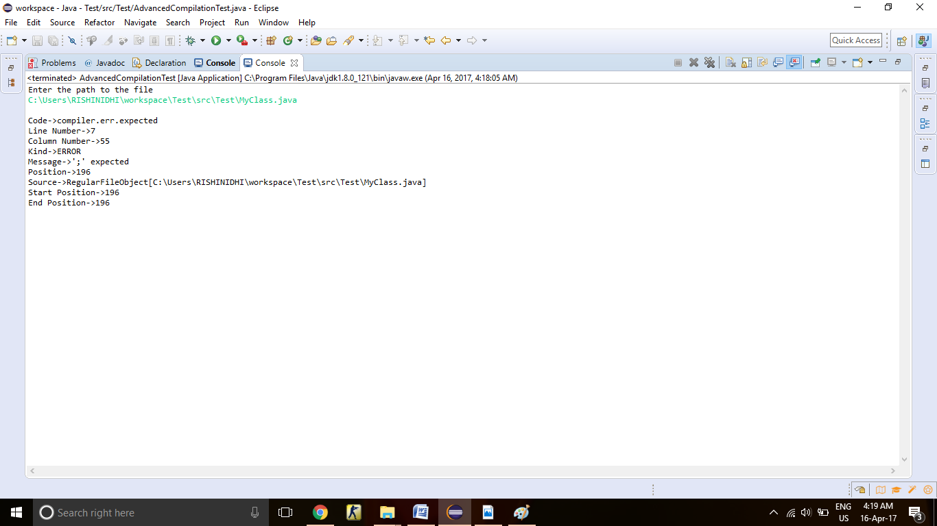
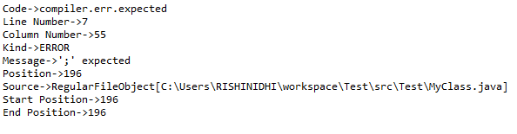
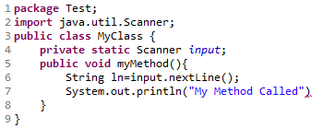
MyClass.java:
MoreErrors.java:
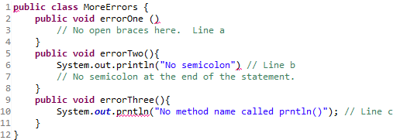
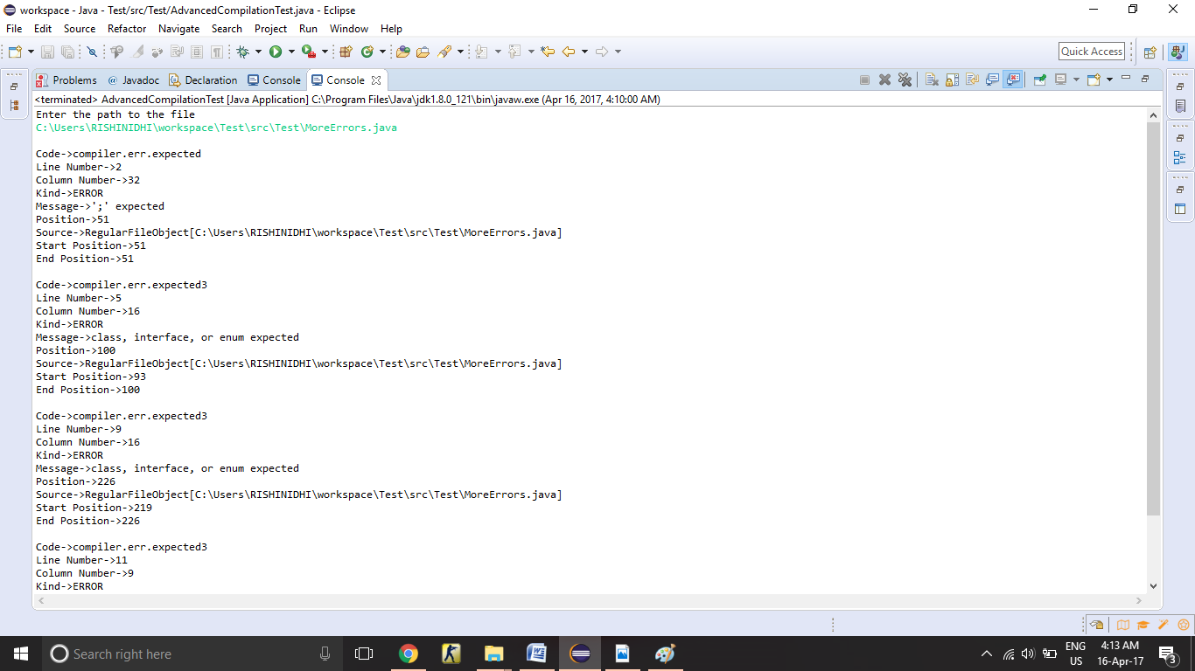
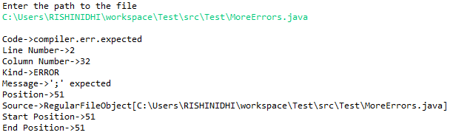
References

- Lexical Analysis- Norms and Exploitations by Patrick Hanks
- http://en.wikipedia.org/wiki/Cosine_similarity
- Compilers Principles Techniques and Tools by Alfred V Aho, Monica S Lam, Ravi Sethi , Jeffrey D Ullman
- http://blog.christianperone.com/2013/09/machine-learning-cosine-similarity-for-vector-space-models-part-iii/

